**MINI PROJECT**

**(2019-2020)**

**AI ChatBot for Health Care**

INSTITUTE OF ENGINEERING AND APPLICATIONS

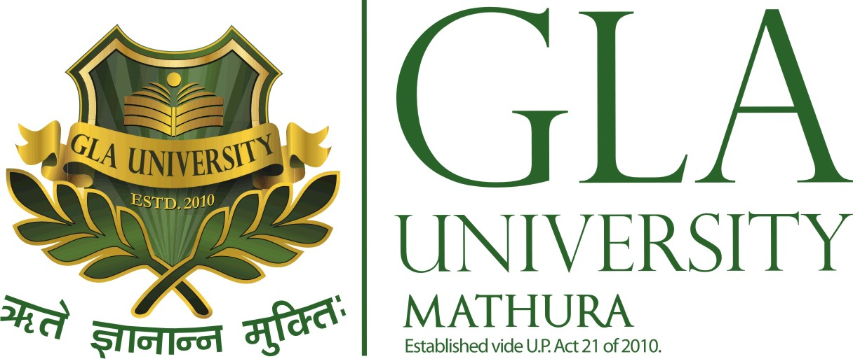

**Submitted To: Submitted By:**

Respected Mr.Amir Khan Nitya Nagpal(171500210)

(Technical Trainer) Kirti Verma(171500162)

AyushShrivastava(171500080)

## Project Aim:

To make a computer program designed to simulate an intelligent conversation with one or more human users.

## About the Project:

In this project, we will showcase how the user can interact with a chatbot to get a response to their queries. Chatbots are computer programs with the designed purpose to have conversations with human users over the world wide web and internet. Many tech programs use conversational agents in their services to help streamline communication with their target audience. Where human agents would have limits on how many customers they can service, chatbots can handle many more customers at once.

This is a basic project that is developed in Python. In this project, we use some Python Libraries. A person just has to put their query to the chatbot which is used for chatting. The system will give appropriate answers to the user. If the answer is found invalid, then there is a system to declare the answer as invalid.

## Motivation:

We sometimes pass our time by chatting with different chatterboxes available on the internet, so to make one of them was indeed an interesting idea. We also had thought of integrating it with speech-to-text and text-to-speech software.

## Requirements:

### Hardware:

* + Minimum 8GB RAM
  + Minimum Core i3
  + Minimum 60GB ROM

### Software:

* + Any Operating System
  + Python IDLE
  + NLTK

## Future Scope:

In the future scope of this project, we can include voice-based queries and answers. The users will have to give voice input and the system will give the text output and while giving it, it will give a voice output as well. By just adding text-to-speech and speech-to-text we can add the above functionality to our project.